PRACTICAL NO.10

Advance GIS Operations 2: Batch Processing using Processing Framework
Automating Complex Workflows using Processing Modeler
Automating Map Creation with Print Composer Atlas

Batch Processing using Processing Framework:
Vector > Geoprocessing Tools.. > Clip.. >
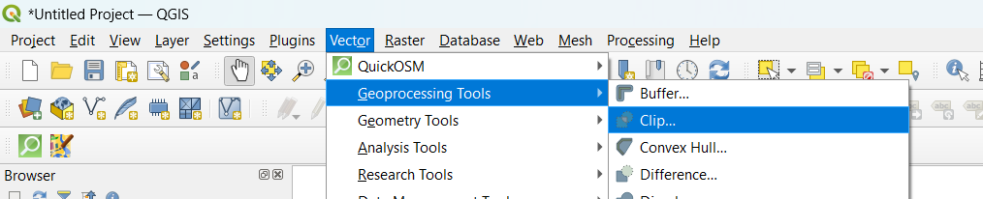

At clip > Click the “Run as batch process” button >
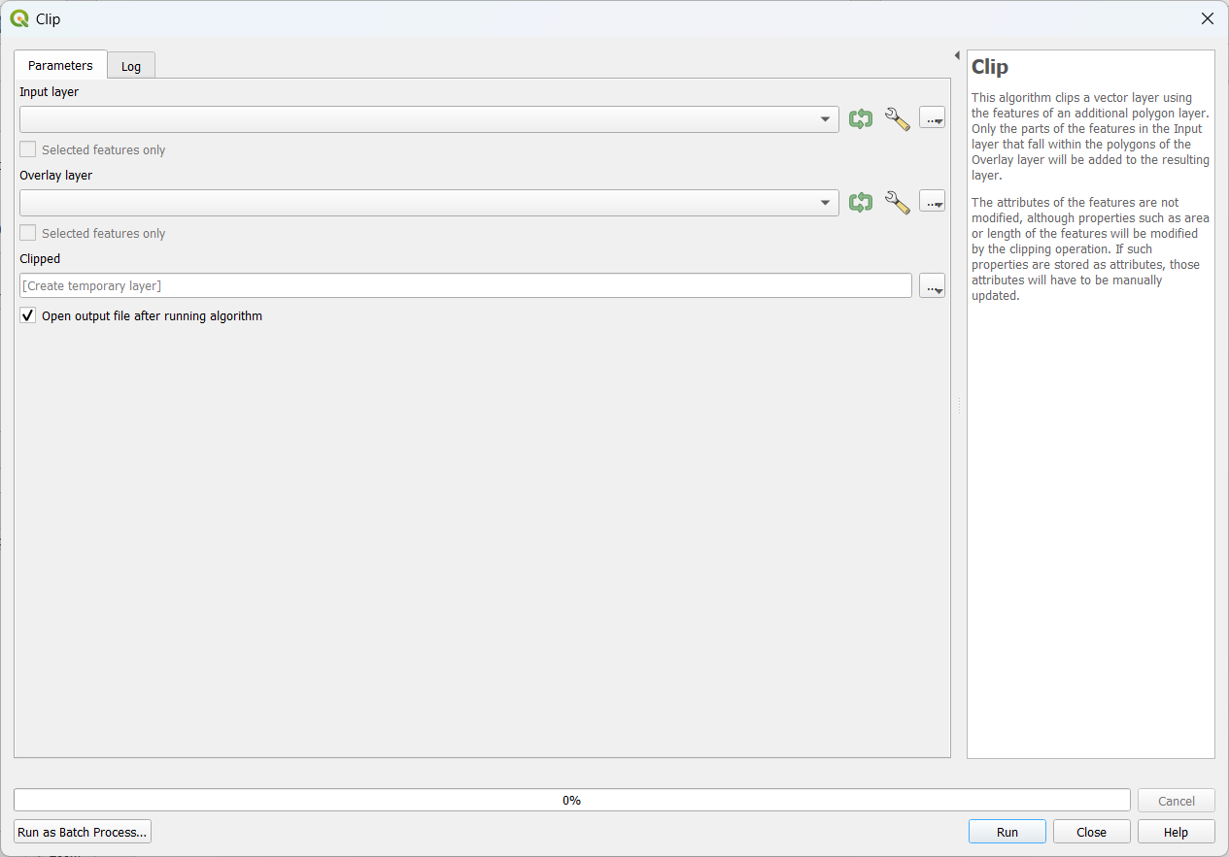

At Batch Processing : Add Input layer:ne_10m_rivers_lake_centerlines.zip ,Overlay layer : IND_adm.zip and Clipped : clippedne_10m_rivers_lake_centerlines.gpkg > Autofill mode : Fill with parameter values and Parameter to use : Input layer > Ok >
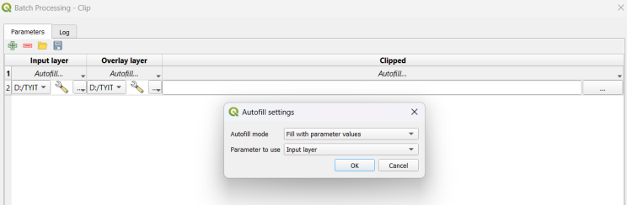

Add another row > Add Input layer:ne_10m_populated_places_simple.zip ,Overlay layer : IND_adm.zip and Clipped : clippedne_10m_populated_places_simple.gpkg > Autofill mode : Fill with parameter values and Parameter to use : Input layer > Ok >
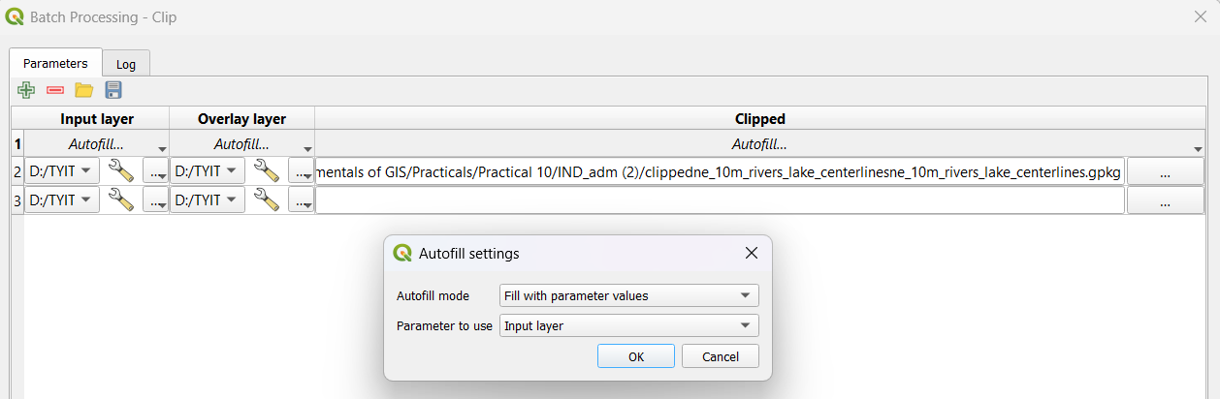

After Adding two rows > Click at Checkbox of “Load Layers on completion” > Run >
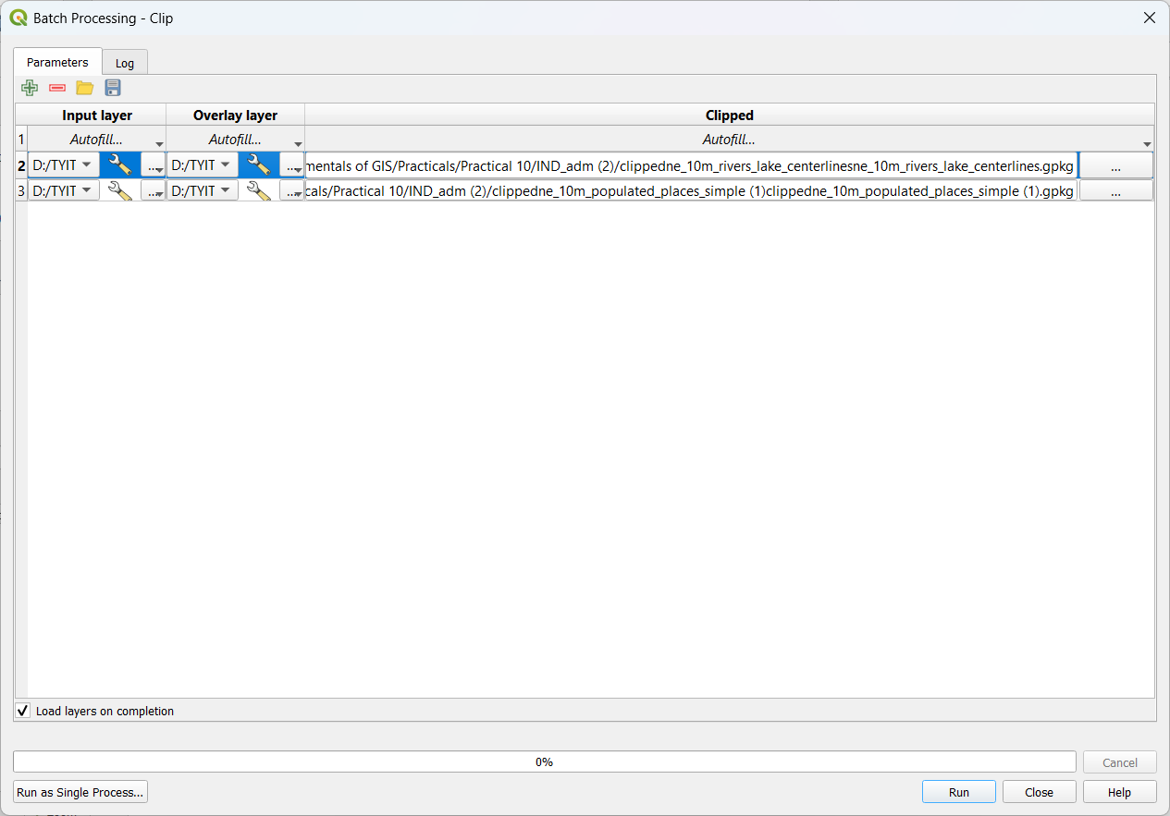

Batch processing window >
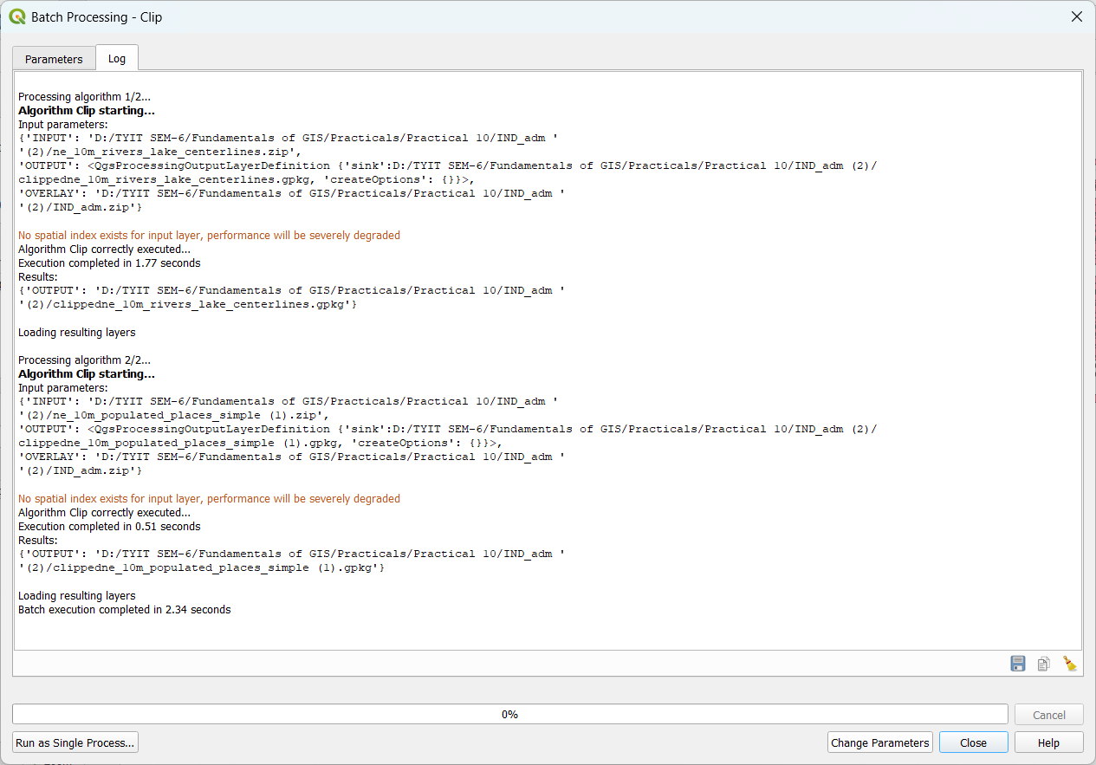

Output After clipping >
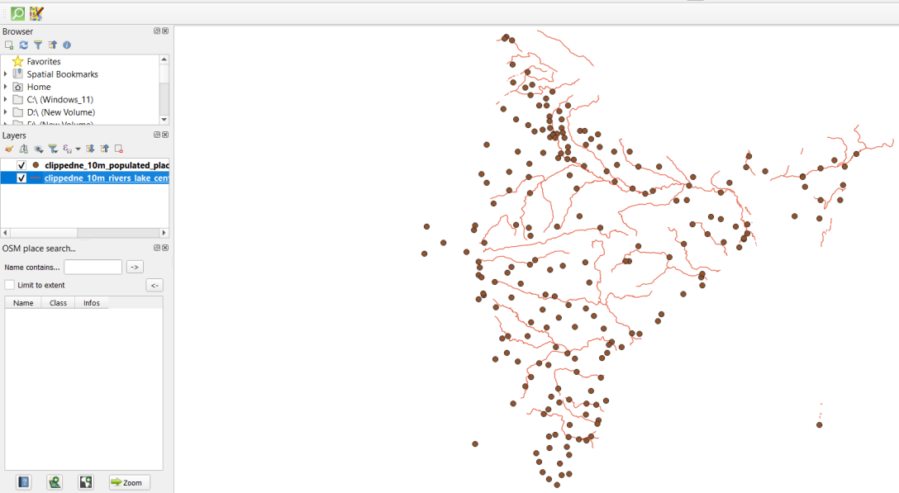

Automating Complex Workflows using Processing Modeler:
Processing > Graphical Modeler >
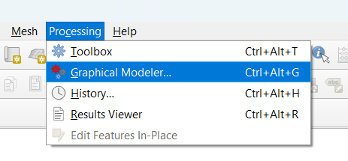

Select Raster Layer at Inputs > Give Description > Ok
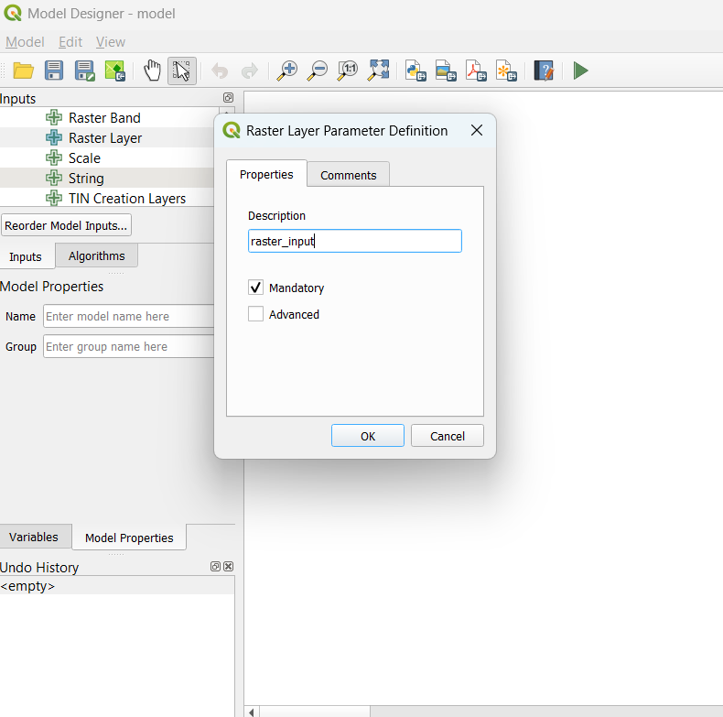
Output after adding raster input >
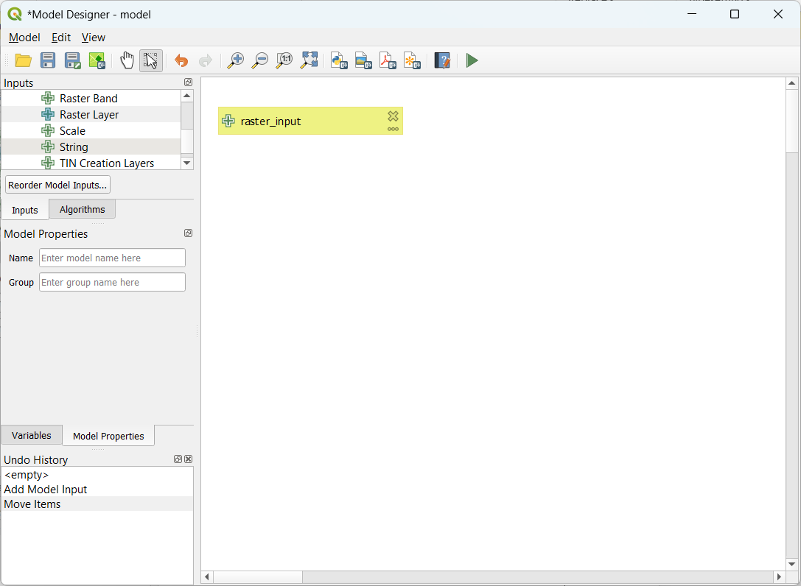

At Algorithms Select Majority/Minority Filter >select raster_input for model input > ok >
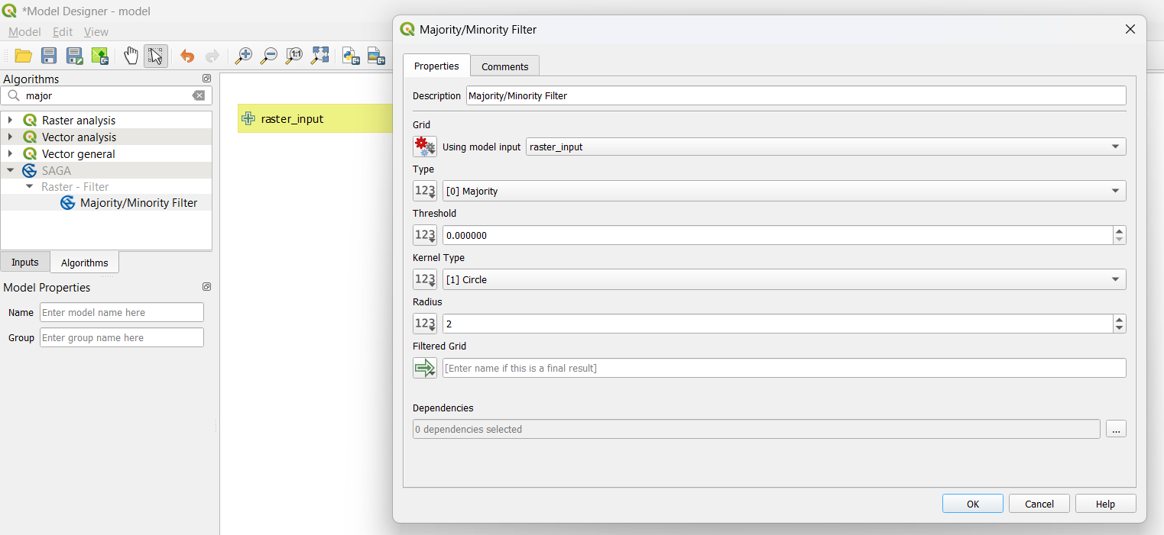

At Algorithms Select Polygonize > select “Majority/Minority Filter” for input layer > Band number : 1 > Name of Field to create : DN > ok >
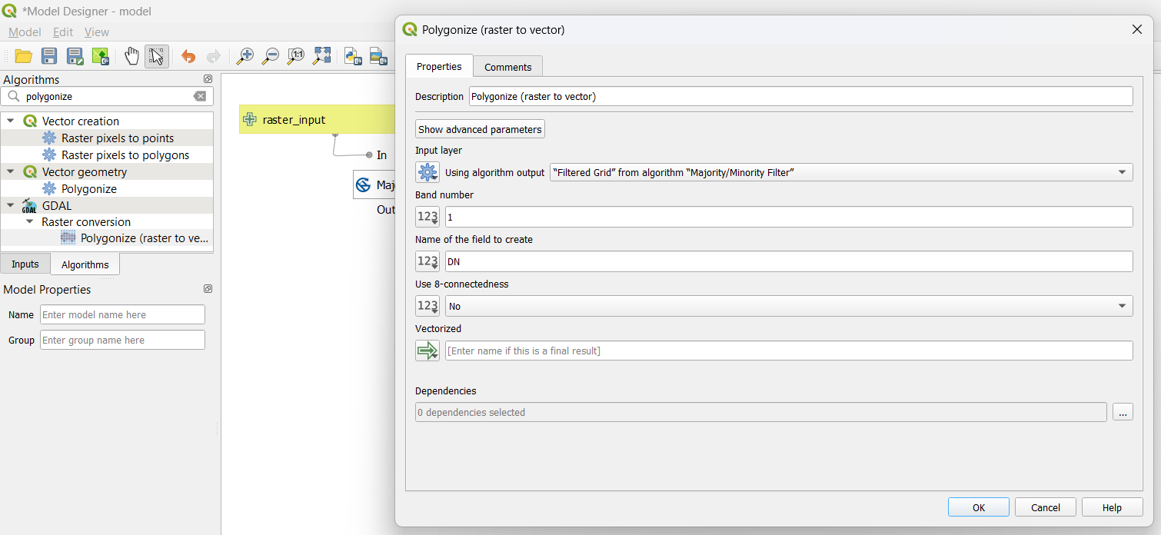

At Algorithms Select Extract by attribute > select “Polygonize” for input layer > selection attribute : DN > Operator : = > Value : 12 > ok >
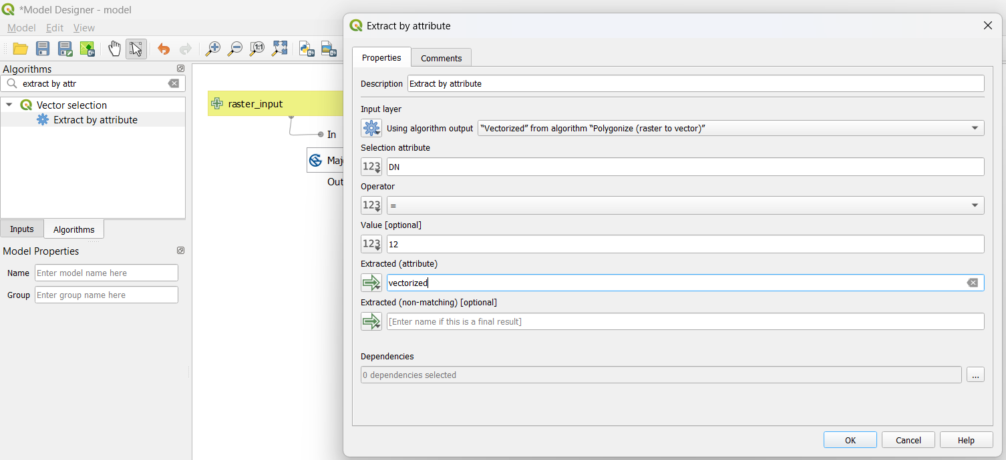

Output after adding Input and algorithms in model >
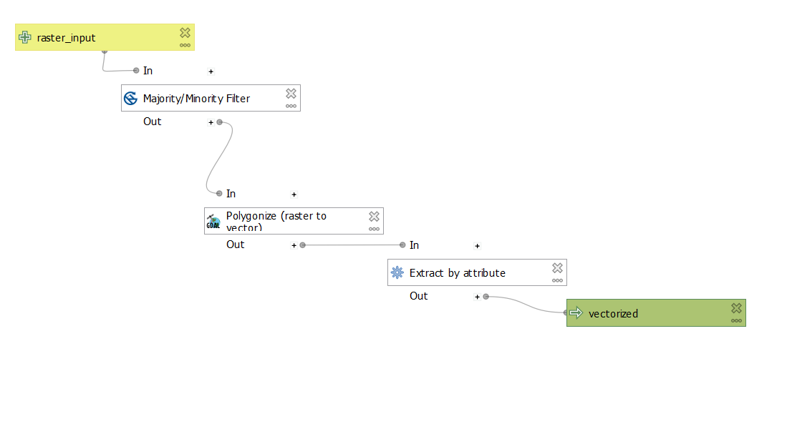

Save the model at default location >
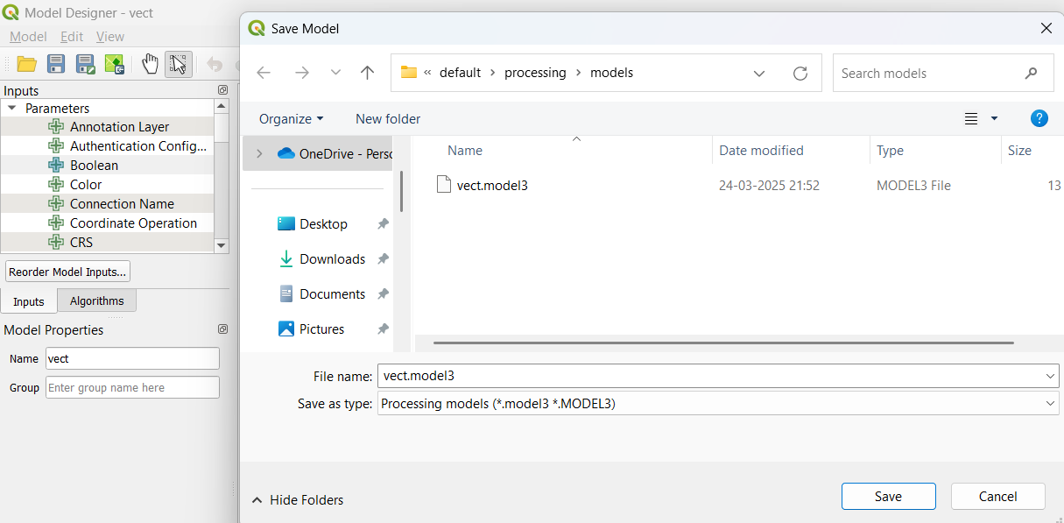

Layer > Add Layer > Add Raster Layer >
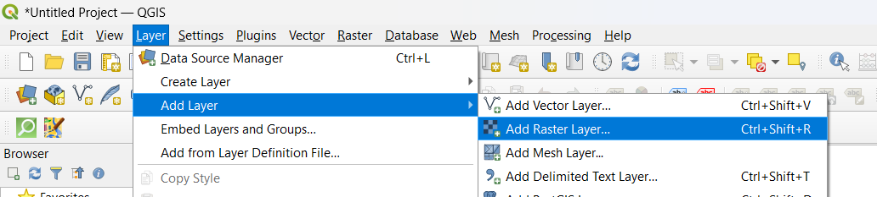

Select “LC_hd_global_2001.tif.gz” >
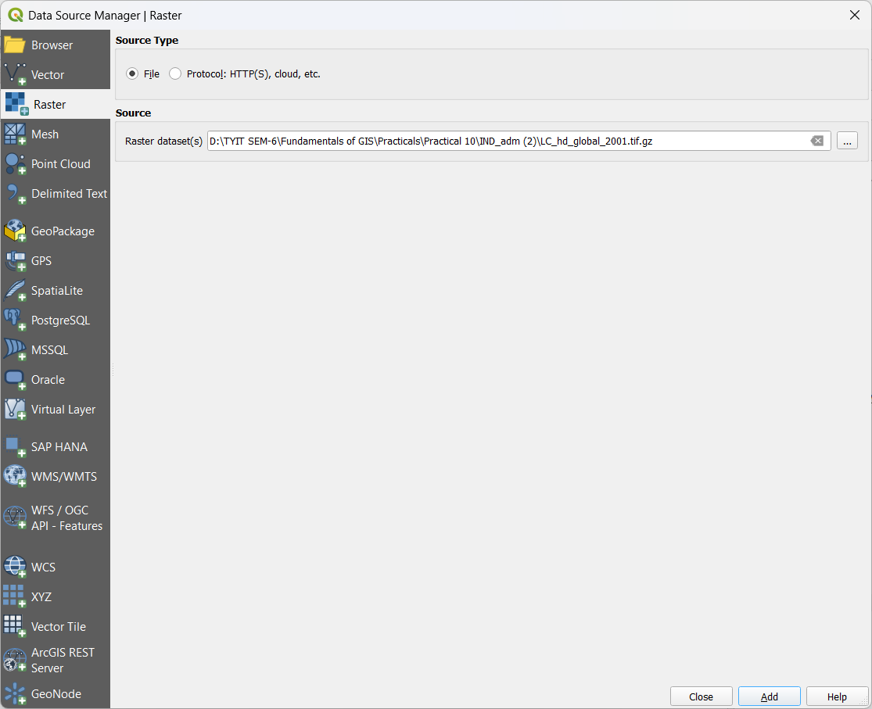

Output after adding Vector LC_hd_global_2001.tif.gz >
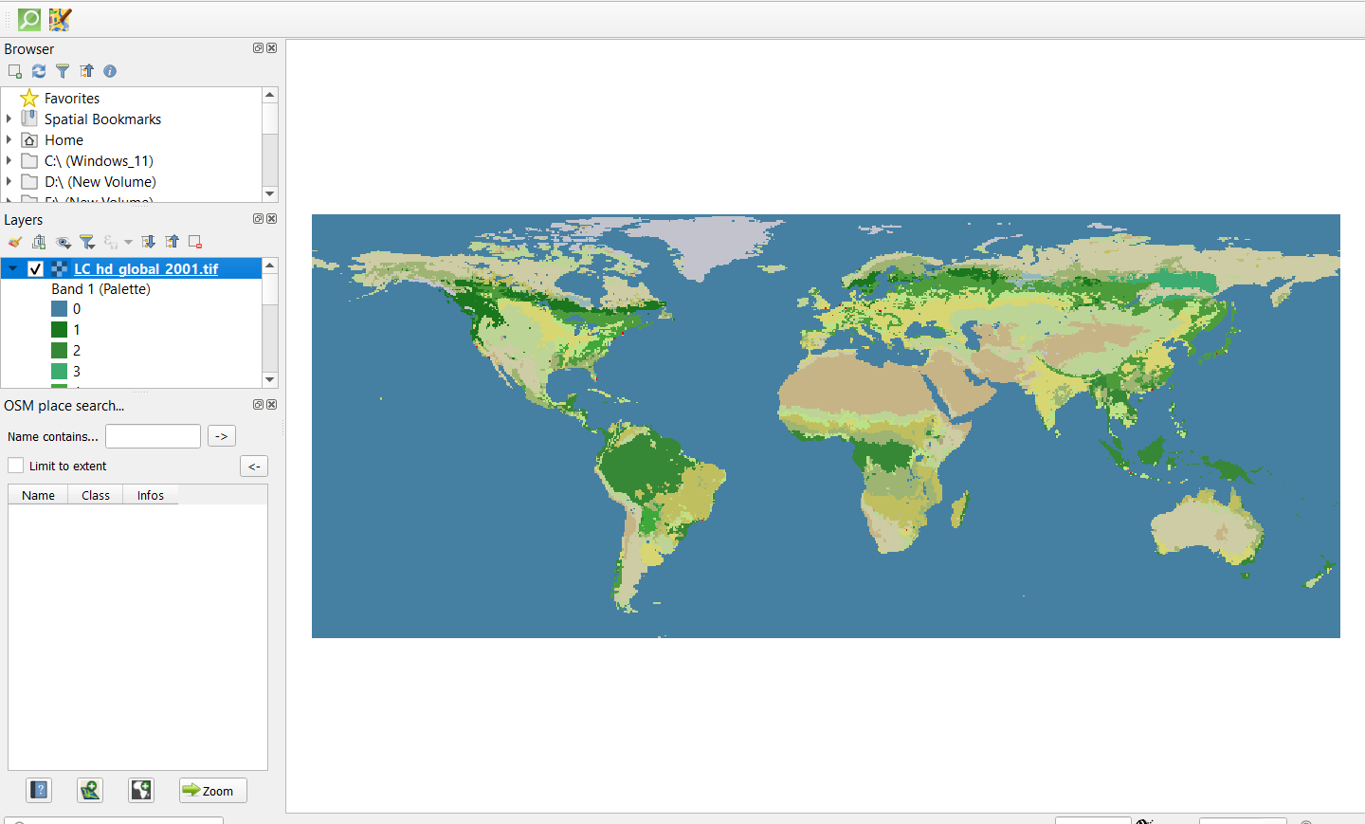

Select “LC_hd_global_2012.tif.gz” >
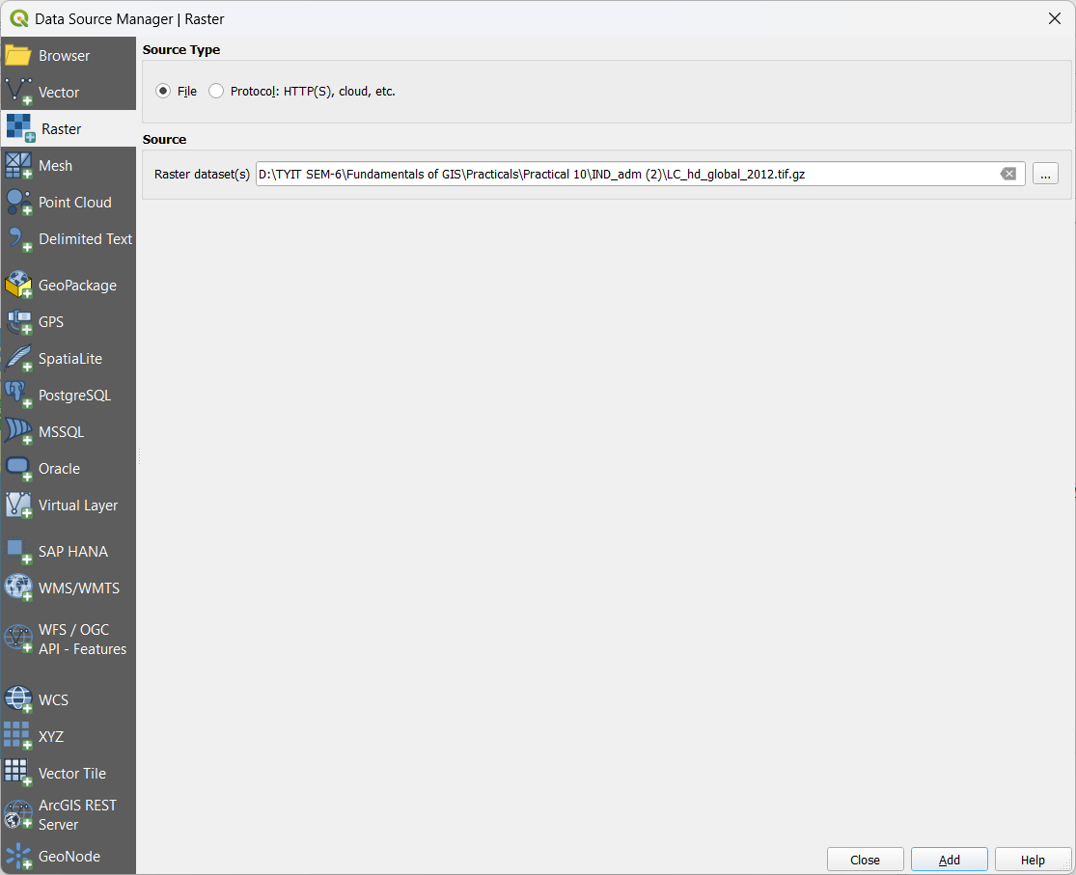

Output after adding “LC_hd_global_2012.tif.gz” >
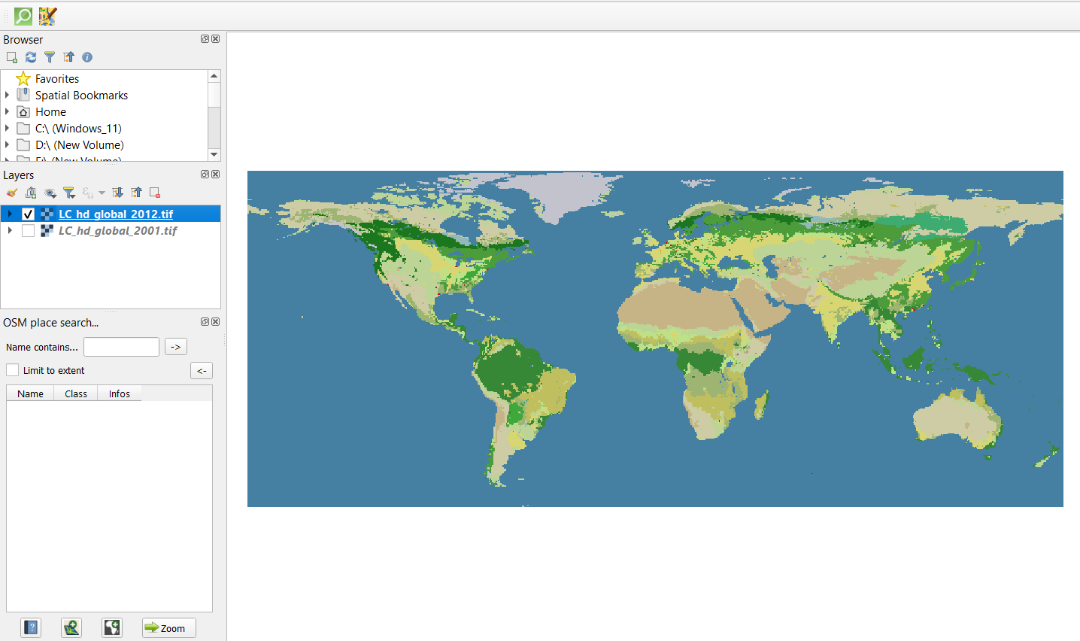

At Processing Toolbox > Clcik vect model > Set raster_input:LC_hd_global_2001.tif > vectorized : model1.gpkg > Run >
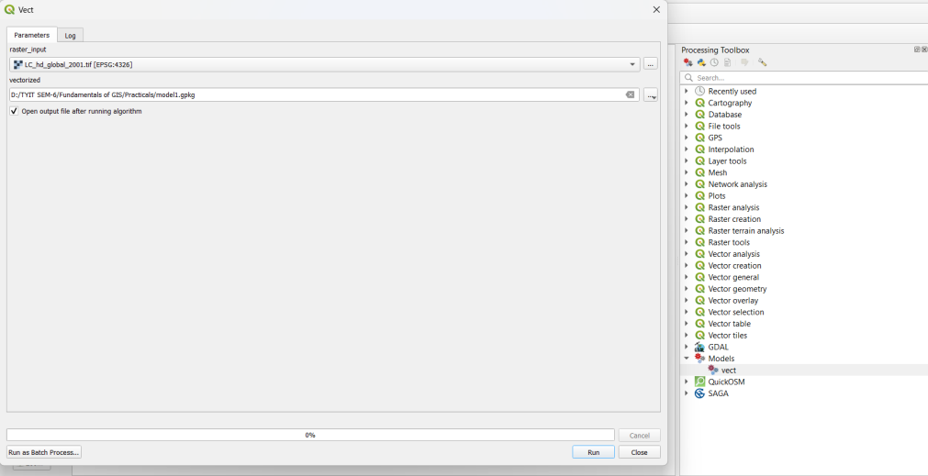

At Processing Toolbox > Clcik vect model > Set raster_input:LC_hd_global_2012.tif > vectorized : model2.gpkg > Run >
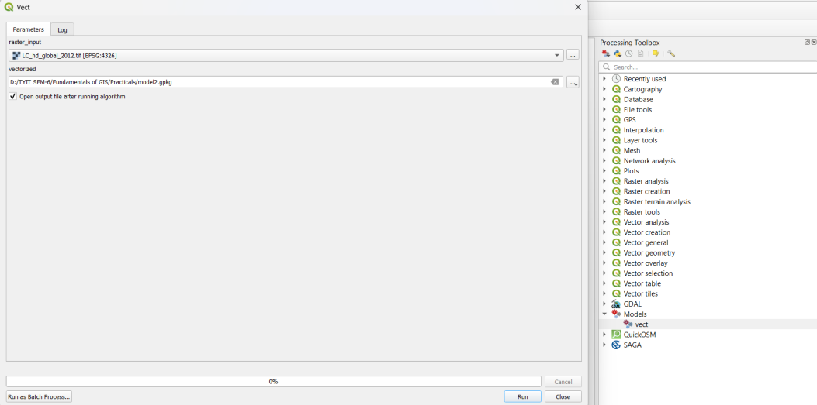

Output after adding model1 and model 2 >
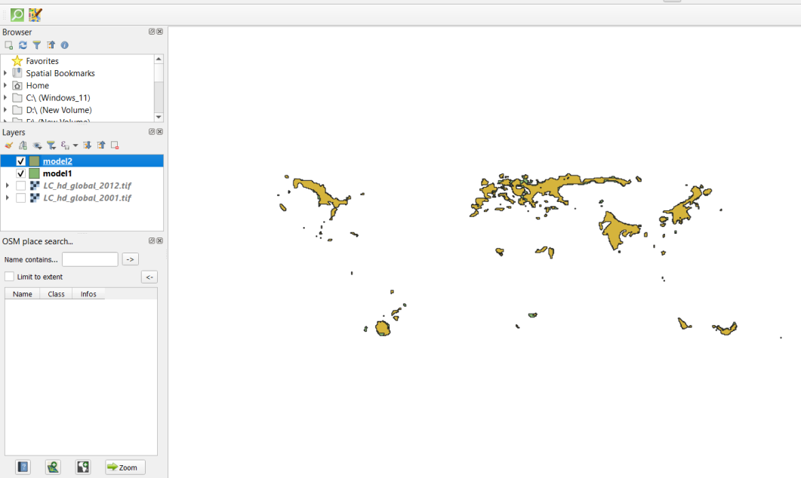

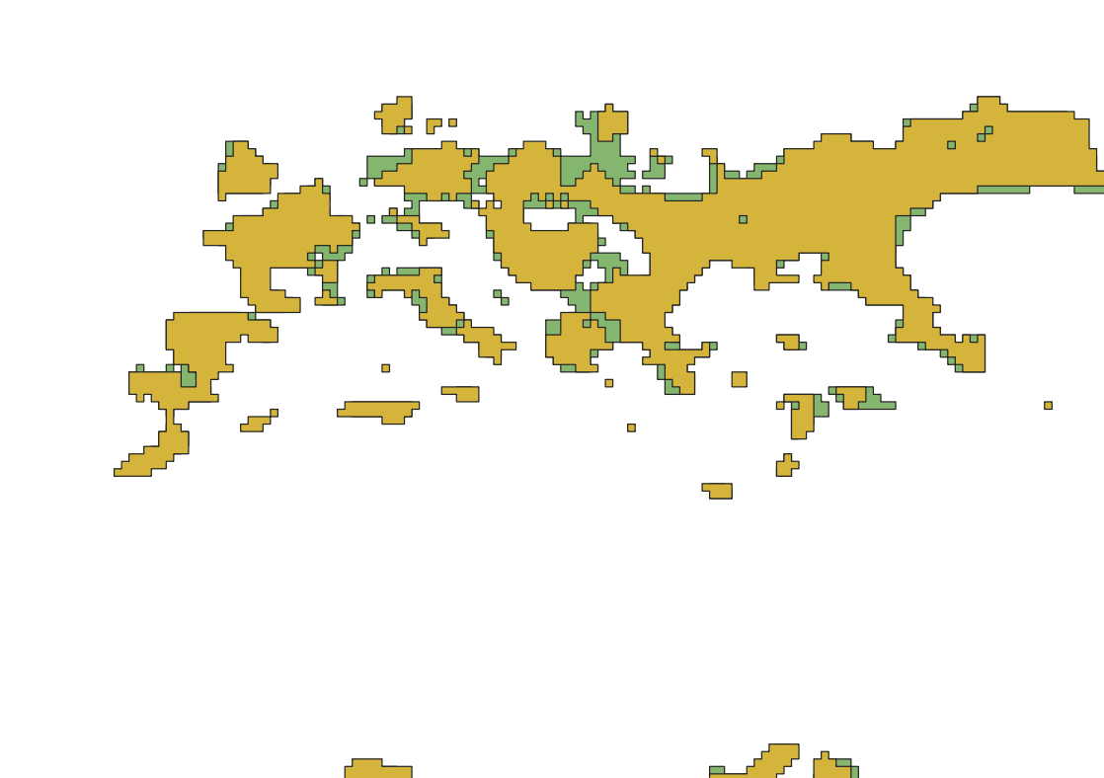

Automating Map Creation with Print Composer Atlas:
Add Layer > new vector layer > HI_Wetlands.shp
Add Layer > new vector layer > country10.shp
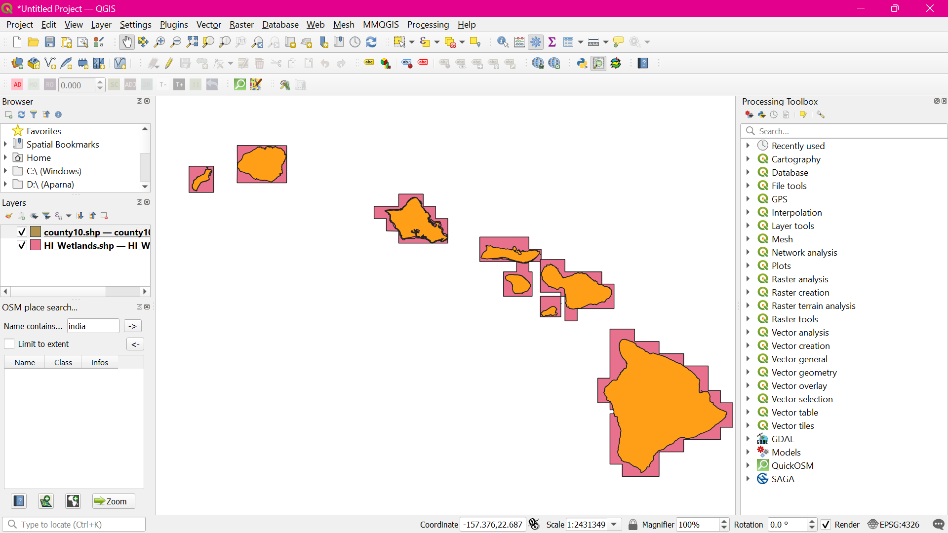

Project > New Print Layout
Add Item > Add Map
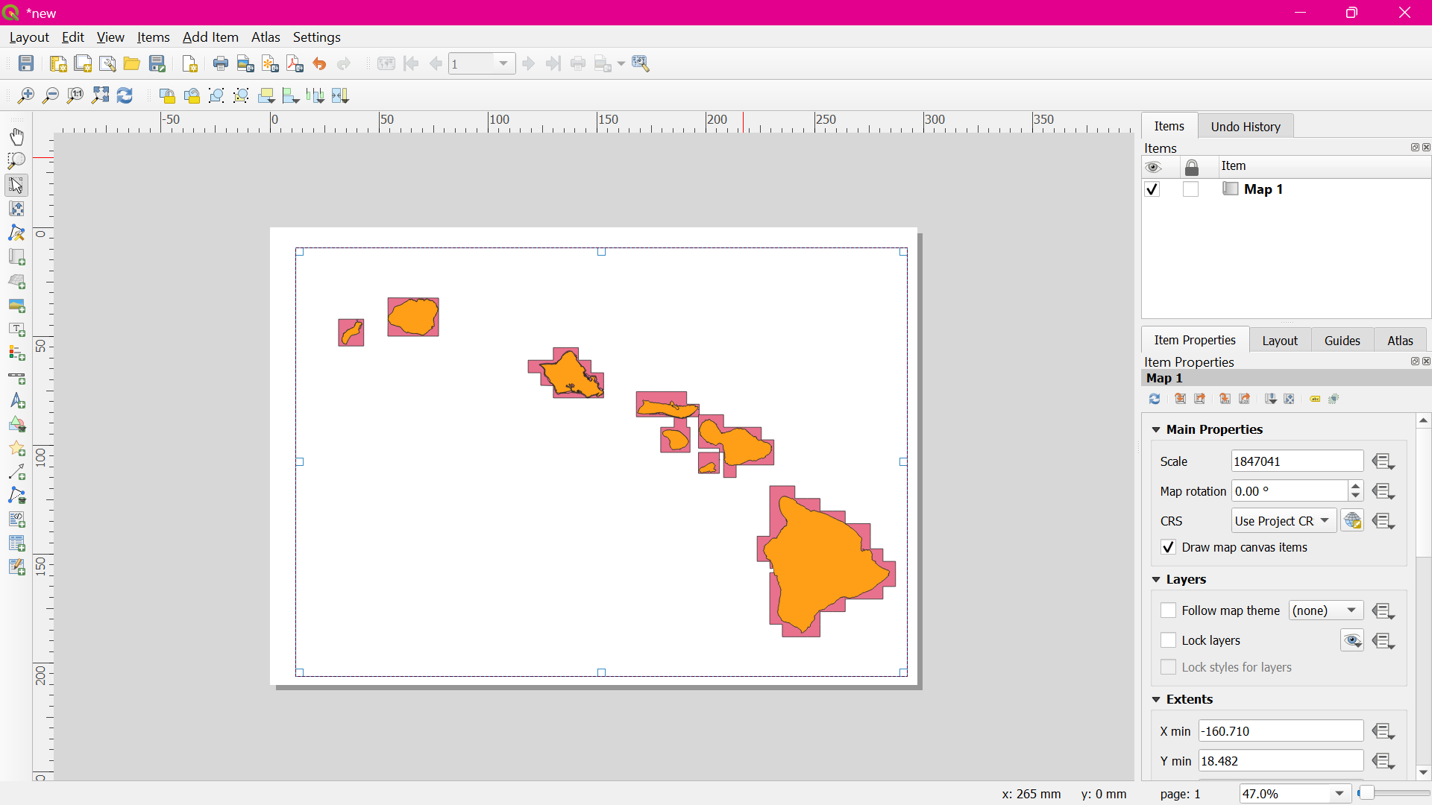

Switch to the Atlas tab. Check the Generate an atlas box. Select the county10 as the Coverage layer. An also check the Hidden coverage layer box
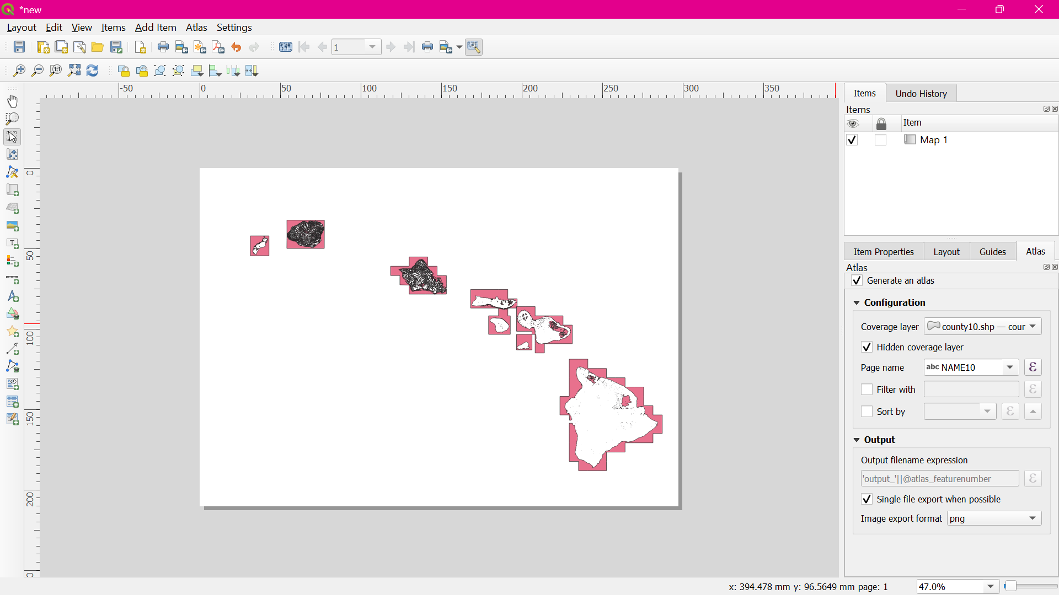

- Go to Atlas > Preview Atlas.
- Go to Add Item > Add Label.
- Under the Item properties tab, click Insert an expression... button.
- Add an expression like below and click OK. concat('County of ', "NAME10")
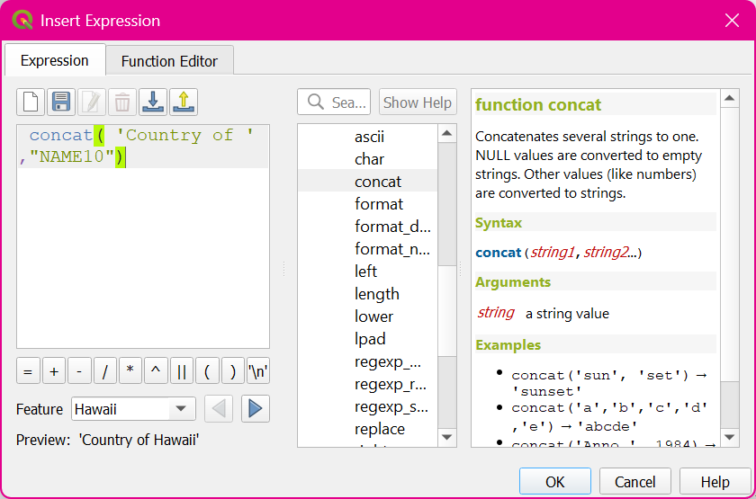

Adjust the font size to your liking.
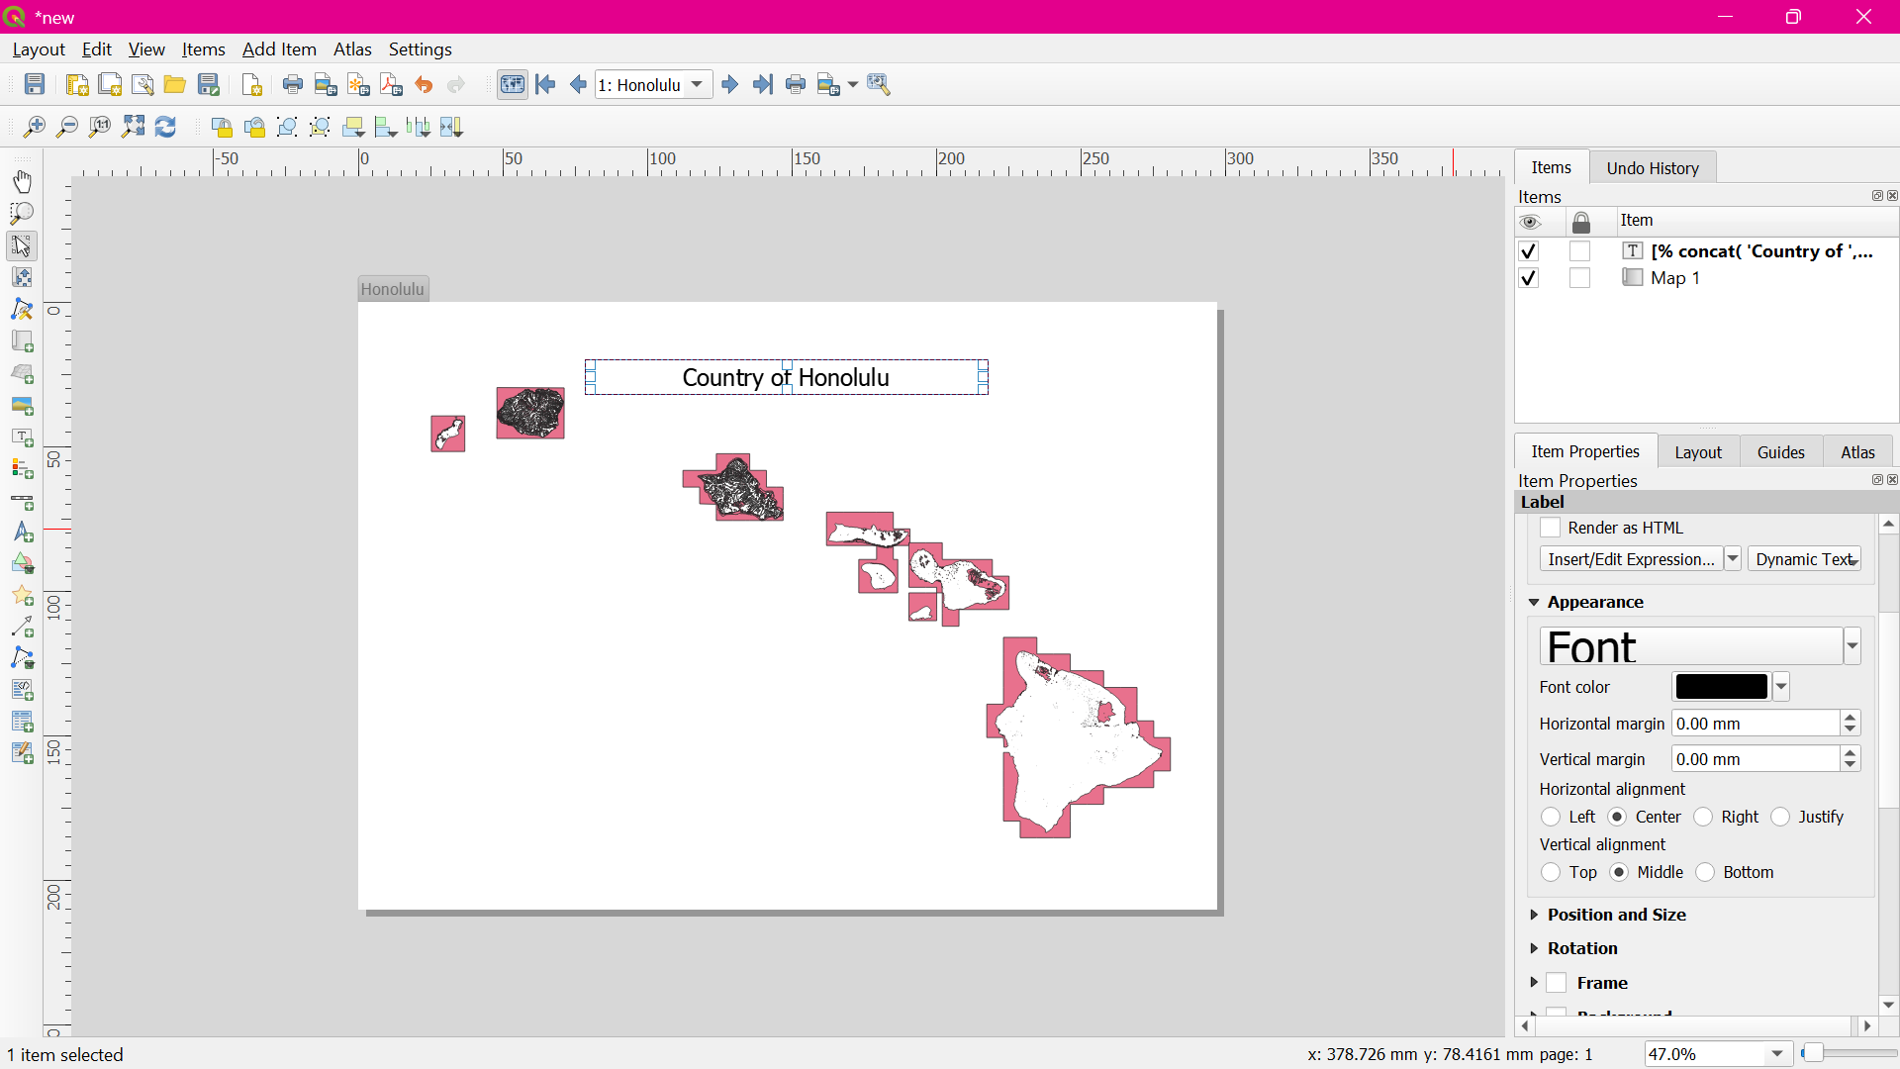

Add another label and enter Wetlands Map under the Main properties. Since there is no expression here, this text will remain the same on all maps.
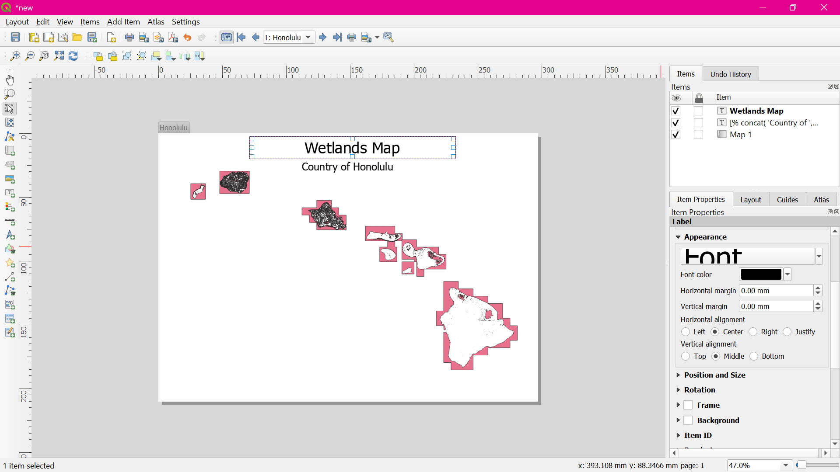

Switch to the main QGIS window. Right-click the county10 layer and select Properties.
In the Style tab, select the Inverted polygons renderer. Select white as the fill color and click OK.
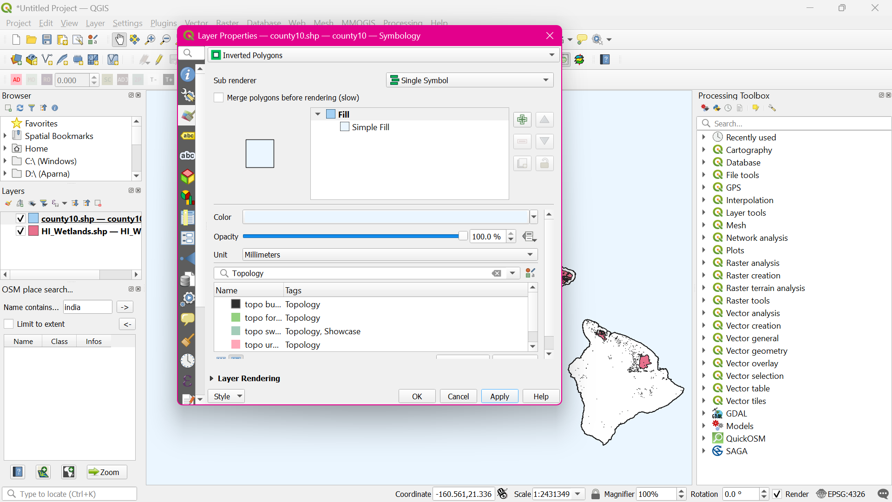

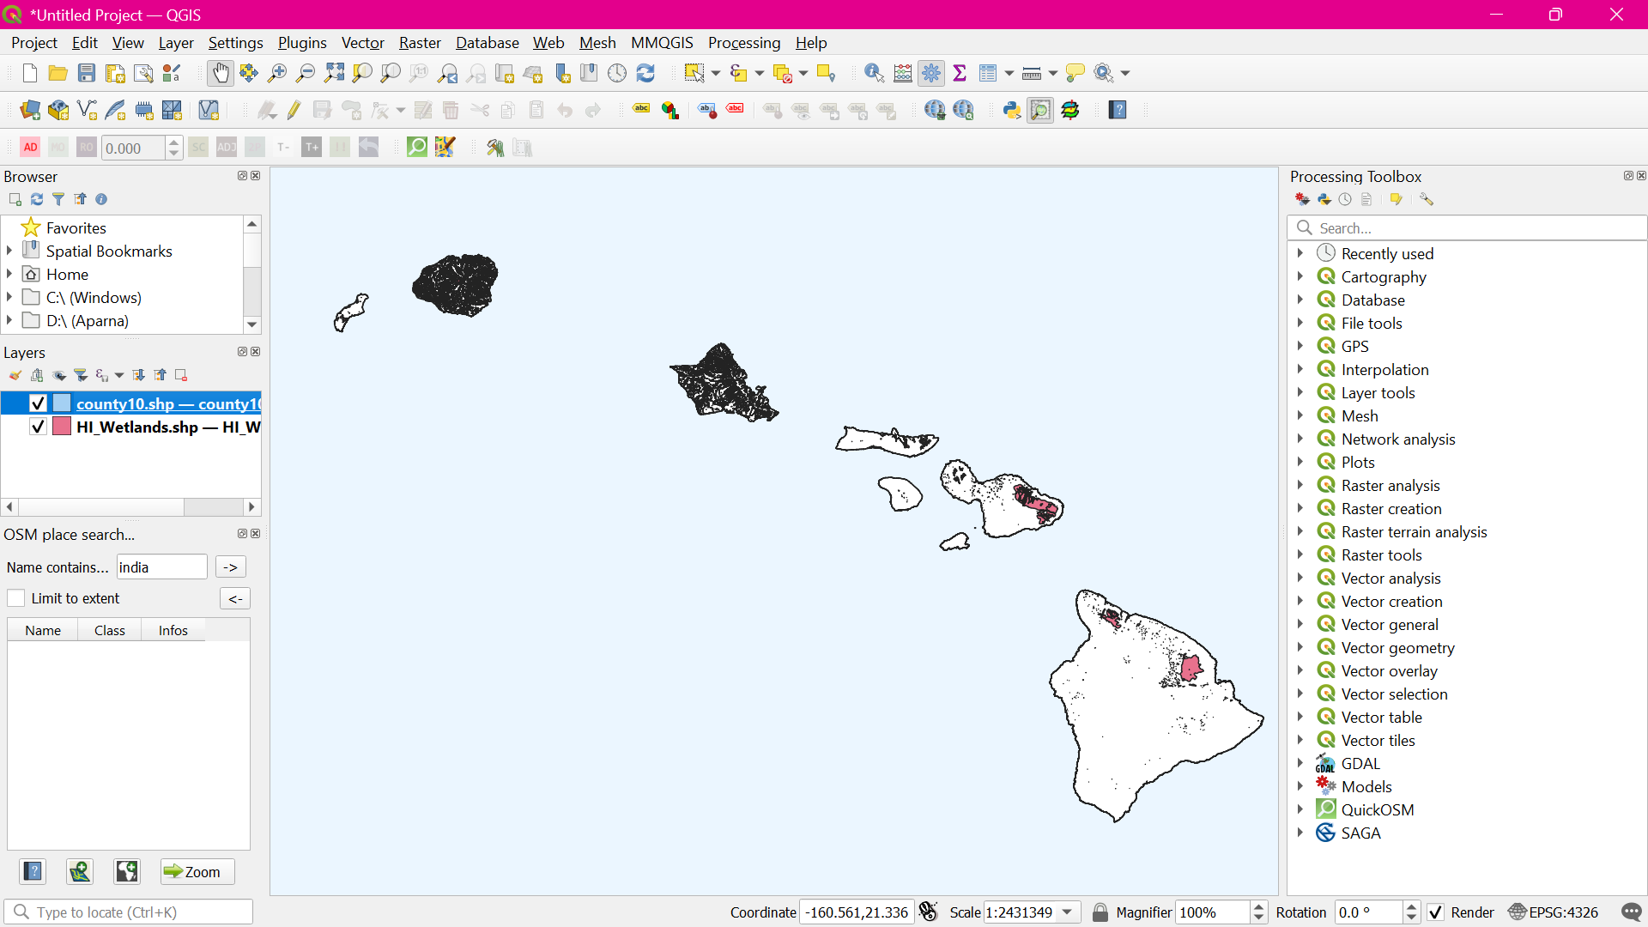

Switch to the Print Composer window. If we want the effect of the inverted polygons to show, we need to uncheck the Hidden coverage layer box under Atlas generation.
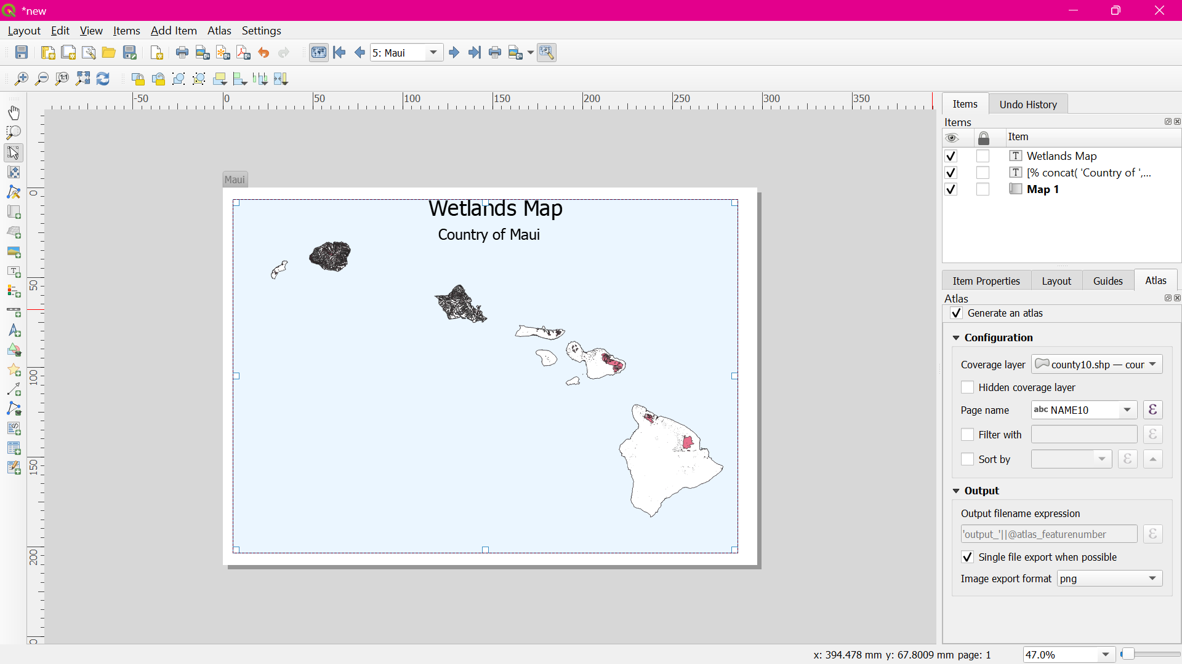

- Switch to the main QGIS window. Right-click the county10 layer and select Properties.
- In the Style tab, select Rule-based renderer as the Sub renderer. Double-click the area under Rule.
- In the Expression string builder, expand the Atlas group of functions.
- Enter the expression as : $id=$atlas_featureid
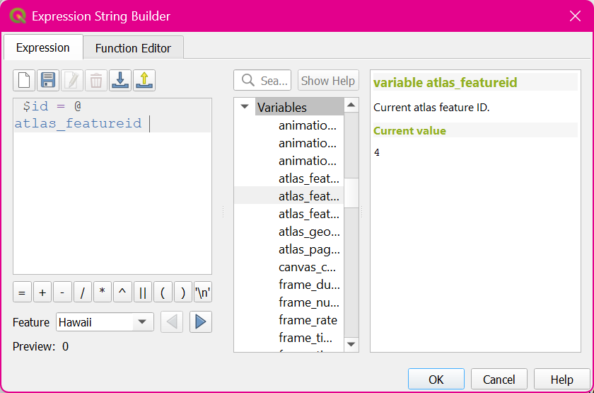

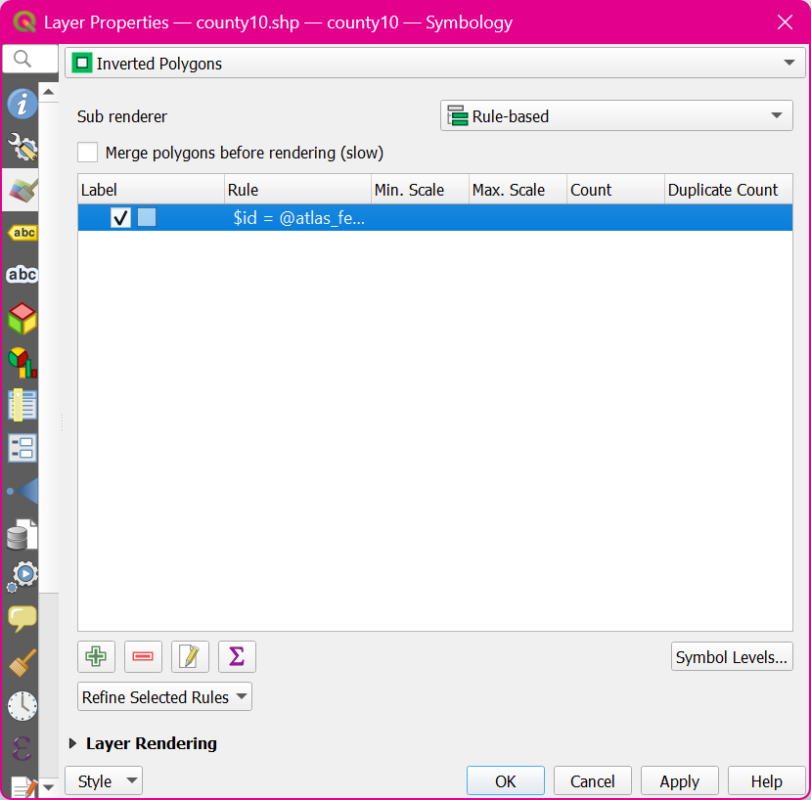

Back in the Print Composer window, click the Update preview button under Item properties tab to see the changes
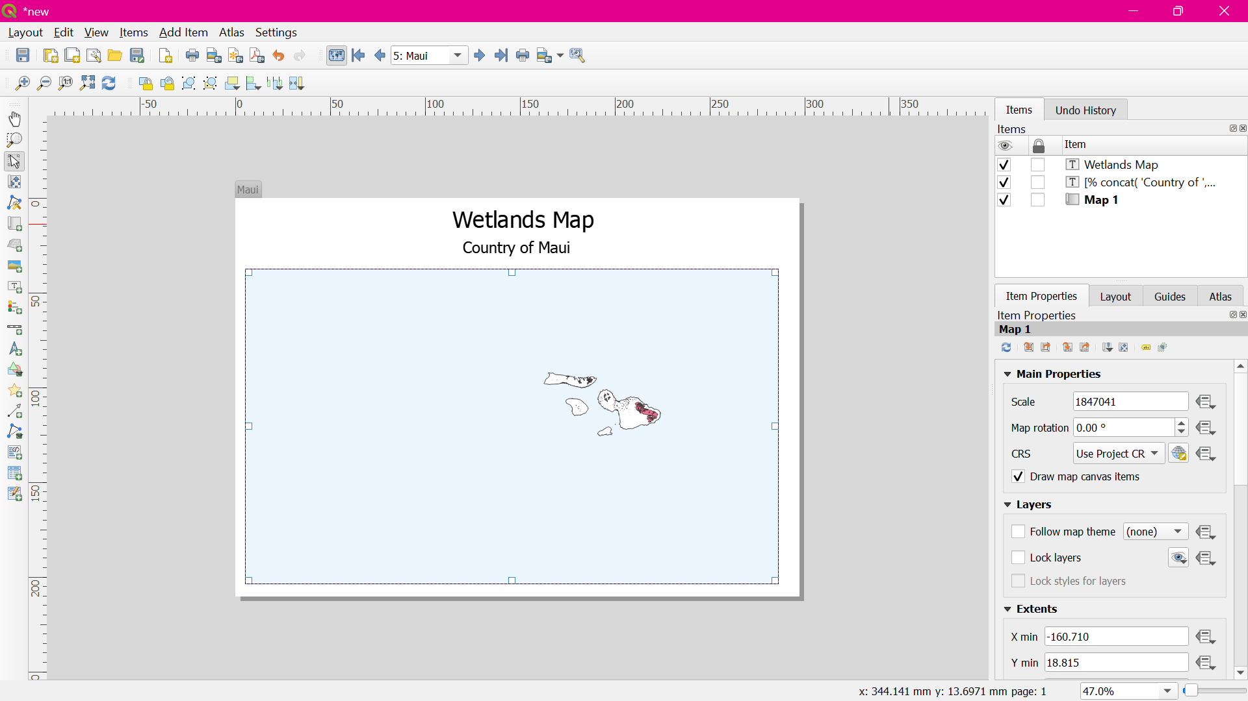

Go to Add Item > Add Label and select the area on the map. Click Insert an expression button.
Enter the expression as: concat('Created on: ', to_date($now))
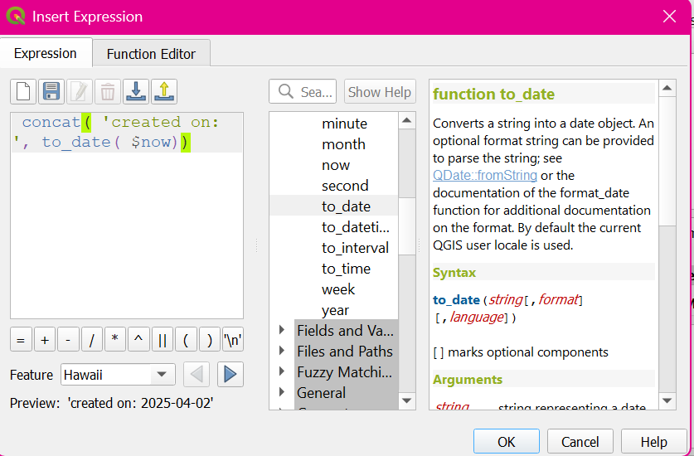

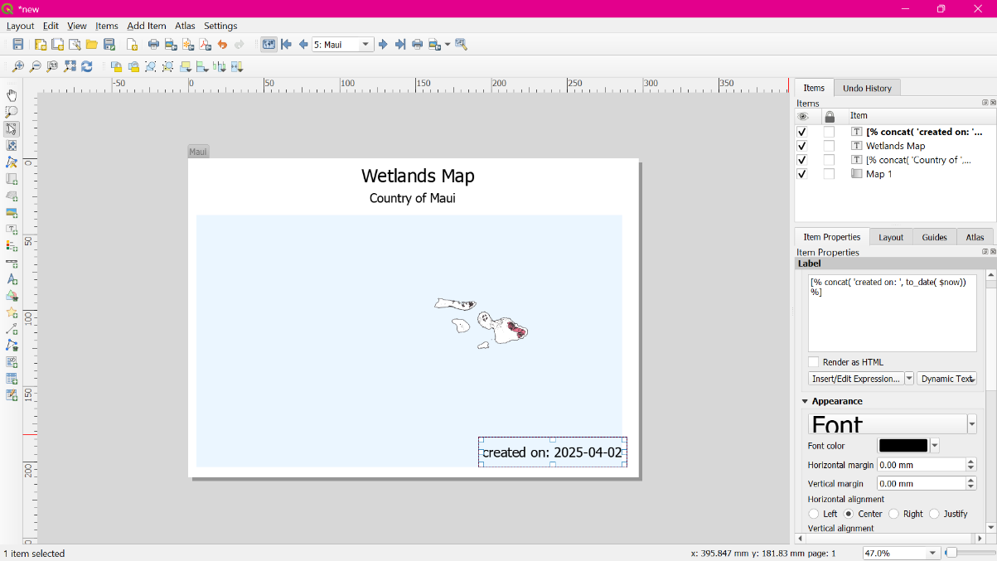

Once you are satisfied with the map layout, go to Atlas > Export Atlas as Images.
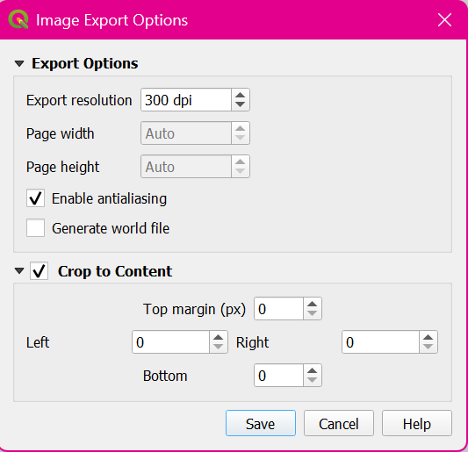

Here are the map images for reference.
